AFROTC Detachment 842

Spring 2024

Commissioning Ceremony



The University of Texas at San Antonio

17 May 2024

**Sequence of Events**

Arrival of Official Party

National Anthem

Invocation

Opening Remarks

Guest Speaker

Commissioning Ceremony

Closing Remarks

Air Force Song

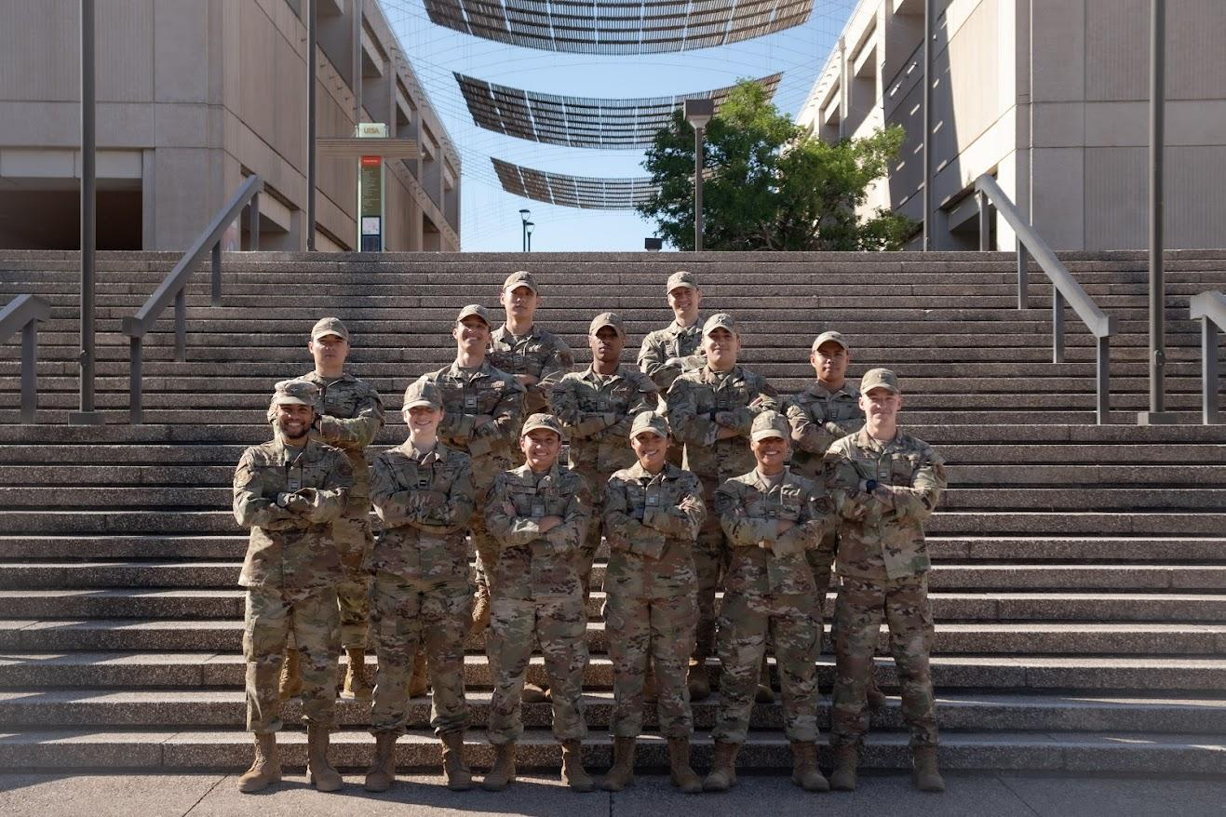

**Detachment 842 Cadre**

Col Gregory Cyrus

Mr. Agustin Llano

Maj Tina-Rose Cavazos

Capt Landon Prendergast

Capt Heather Glover

Capt Jennifer Hurt

TSgt Erren Barnes

SSgt Rachel Mangru

SSgt Rashaad Taylor

Ms. Maisha Rahman



Commander

Program Manager

Director of Operations

Operations Flight Commander

Education Officer

Recruiting Officer

NCOIC, Detachment 842

NCOIC, Personnel

NCOIC, Administration

Administrative Assistant

**BRIGADIER GENERAL JEFFREY W. NELSON**

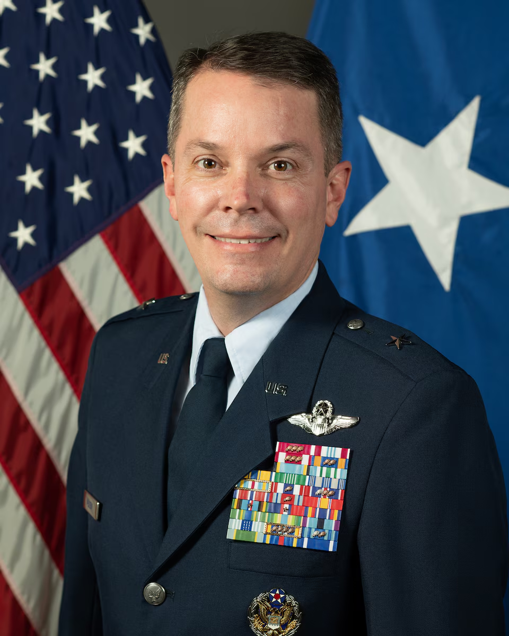

Brig. Gen. Jeffrey W. Nelson is the Deputy Commander, Nineteenth Air Force, Joint Base San Antonio-Randolph, Texas. Nineteenth Air Force is composed of 32,000 Total Force personnel and 1,608 aircraft assigned to 17 Total Force Wings located across the U.S. He is responsible for more than 45% of the U.S. Air Force’s annual flying hour program, which trains 27,000 U.S. and allied aircrew annually, flying 23 different types of aircraft. Brig. Gen. Nelson has commanded at the Squadron level and multiple times at the Wing level. He has flown numerous combat missions, logging more than 500 combat hours and has over 4,400 total flying hours. In 1997 Brig. Gen. Nelson received his commission as a distinguished graduate of the United States Air Force Academy with a Bachelor of Science Degree in Civil Engineering.

**Spring 2024 Commissioning Class**

Betzel, Joseph (UTSA)

Graduated with a Bachelor’s Degree in Kinesiology. He will be assigned to Vance Air Force Base, Oklahoma for Undergraduate Pilot Training.

**Commissioned by:** Major Tina-Rose Cavazos, USAF

**Pinned By:** Kandace Betzel, Maurice Betzel, & Andrew Betzel

**First Salute:** Senior Airman Logan Morin, USAF

Braxton, Jamal (UTSA)

Graduated with a Bachelor’s Degree in Psychology. He will be assigned to Barksdale Air Force Base, Louisiana as an Aircraft Maintenance Officer.

**Commissioned by:** First Lieutenant Matthew Hageman, USSF

**Pinned by:** Lawrence Braxton, Ahllam Braxton, & Ilias Braxton

**First Salute:** Master Sergeant (Retired) Lawrence Braxton, USAF

Burns, Joseph (UTSA)

Graduated with a Bachelor’s Degree in Multidisciplinary Studies. He will be assigned to Keesler Air Force Base, Mississippi as a Cyber Warfare Officer.

**Commissioned by:** Colonel Gregory Cyrus, USAF

**Pinned by:** Thomas Burns, Gina Tate, & Violette Ramirez

**First Salute:** Master Sergeant Martin Delpaz, USAF

Choi, Woo (UTSA)

Graduated with a Bachelor’s Degree in Kinesiology. He will be assigned to Keesler Air Force Base, Mississippi as a Cyber Officer.

**Commissioned by:** Major David Seok, USAF

**Pinned by:** Jaehak Choi, Eunyoung Lee, & Jungtae Lee

**First Salute:** Airman First Class Jun Kim, USAF

Garza, Roberto (UTSA)

Graduated with a Bachelor’s Degree in Health. He will be assigned to Goodfellow Air Force Base, Texas as an Intelligence Officer.

**Commissioned by:** Captain Landon Prendergast, USAF

**Pinned by:** Angelic Garza, Matthew Garcia, & Jessica Barraza

**First Salute:** Technical Sergeant (Retired) Roberto Garza, USAF & Petty Officer

Second Class Anisia Guerrero, USN

Harris, Jackie (UTSA)

Graduated with a Master’s Degree in Business Administration. He will be assigned to Hanscom Air Force Base, Massachusetts an Acquisitions Manager.

**Commissioned by:** Major Romonte Sullivan, USAF

**Pinned by:** Jackie Harris, Senetra Harris, & Tierra Farrior

**First Salute:** Chief Master Sergeant (Retired) Jackie Harris, USAF

Haynes, Shirley (UTSA)

Graduated with a Bachelor’s Degree in Chemistry. She will be assigned to Beale Air Force Base, California as a Finance Officer.

**Commissioned by:** Major Glen Peoples, ANG

**Pinned by:** Joseph Haynes, Erika Haynes, & Alexis Haynes

**First Salute:** Technical Sergeant Carlos Burrell, USAF

Irizarry, Sophia (UTSA)

Graduated with a Bachelor’s Degree in Cyber Security. She will be assigned to Goodfellow Air Force Base, Texas as an Intelligence Officer.

**Commissioned by:** Lieutenant Colonel Ashley Pflug, USA

**Pinned By:** Jose Irizarry, Ivette Irizarry, & David Irizarry

**First Salute:** Airman First Class Avalon Gonzales, USAF

Lane, Brandon (UTSA)

Graduated with a Bachelor’s Degree in Communication. He will be assigned to Randolph Air Force Base, Texas for Undergraduate Pilot Training.

**Commissioned by:** Major Romonte Sullivan, USAF

**Pinned by:** Chonthicha Lane, Ryan Lane, & Sean Lane

**First Salute:** Chief Master Sergeant (Retired) Charles Lane & Chief Master Sergeant

(Retired) Chonthicha Lane, USAF

Nergaard, Kristin (MSU)

Graduated with a Bachelor’s Degree in Aviation & Aerospace Science. She will be assigned to Vandenburg Space Force Base, California as a Nuclear & Missile Operations Officer.

**Commissioned by:** Colonel Gregory Cyrus, USAF

**Pinned by:** Kathryn Nergaard & Jesper Nergaard

**First Salute:** Rendered on Active Duty

Pacheco, Alexis (UTSA)

Graduated with a Bachelor’s Degree in Psychology. She will be assigned to Misawa Air Base, Japan as a Logistics Readiness Officer.

**Commissioned by:** Major Romonte Sullivan, USAF

**Pinned by:** Natalie Alaniz, Roland Pacheco, Lorenzo Pacheco, & Daniel Pacheco

**First Salute:** Master Sergeant (Retired) Manuel Delgado, USAF

Rodriguez, Francisco (UTSA)

Graduated with a Bachelor’s Degree in Criminology & Criminal Justice. He will be assigned to Randolph Air Force Base, Texas for Undergraduate RPA Training.

**Commissioned by:** Major Romonte Sullivan, USAF

**Pinned by:** Monica Rodriguez, Alex Rodriguez, & Adam Rodriguez

**First Salute:** Chief Master Sergeant (Retired) Frank Rodriguez, USAF

Sadsad, Christian (UTSA)

Graduated with a Bachelor’s Degree in Kinesiology. He will be assigned to Vandenburg Space Force Base, California as a Nuclear & Missile Operations Officer.

**Commissioned by:** Major Romonte Sullivan, USAF

**Pinned by:** Elizabeth Sadsad, Ellimay Sadsad, & Chase Sadsad

**First Salute:** Senior Chief (Retired) Constante Sadsad, USN

**Oath of Office**

I, (state your name),

having been appointed a Second Lieutenant

in the United States Air Force,

do solemnly swear (or affirm)

that I will support and defend the Constitution of the United

States against all enemies, foreign and domestic;

that I will bear true faith and allegiance to the same;

that I take this obligation freely,

without any mental reservation or purpose of evasion;

and that I will well and faithfully discharge the duties

of the office upon which I am about to enter.

So help me God.

**Air Force Song**

Off we go into the wild blue yonder,

Climbing high into the sun;

Here they come zooming to meet our thunder,

At ‘em now, give‘em the gun!

Down we dive, spouting our flame from under,

Off with one helluva roar;

We live in fame or go down in flame.

Hey!

Nothing’ll stop the U.S. Air Force!

*“Det 842…Best in Blue!”*

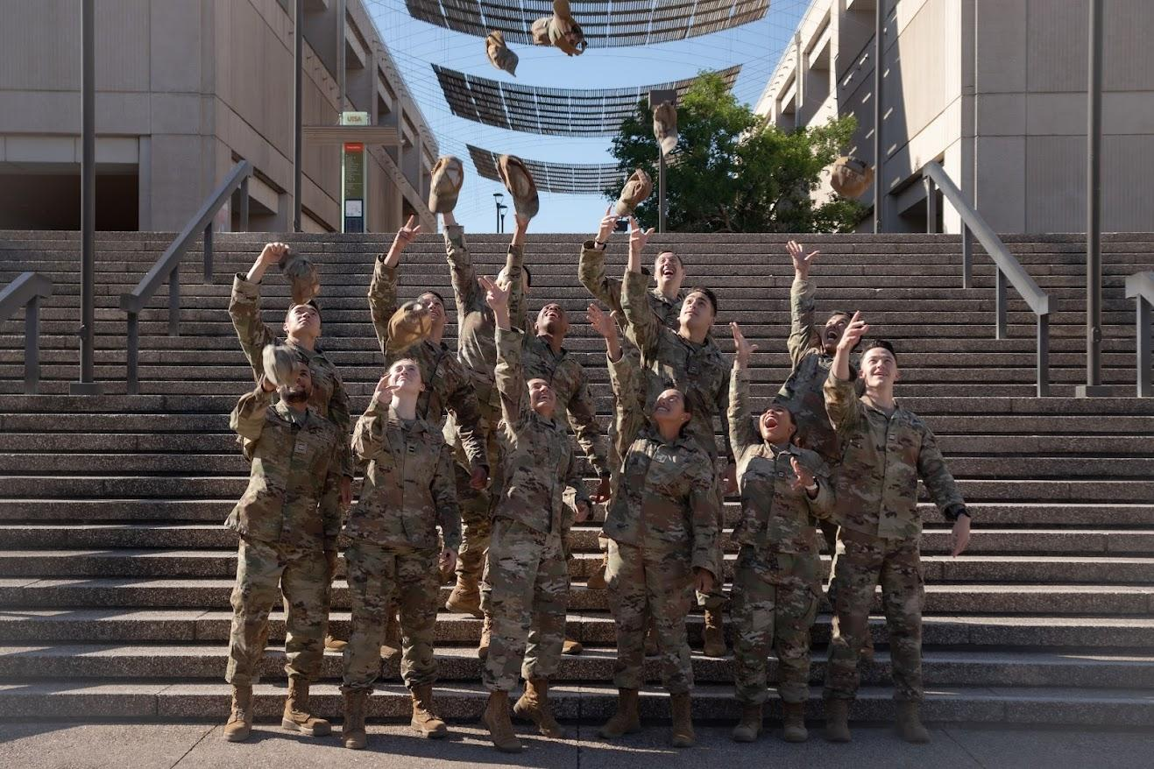

*842…Best in Blue!”*